Dear Educator, Librarian, and Lover of Literature,
This is our Twenty-Fifth Year Celebrating Children’s Literature. We have amazing, award winning presenters: Sophie Blackall, Alan Gratz, Laura Vaccaro Seeger, and James Yang. Sophie Blackall is a Caldecott award winning illustrator and author. Alan Gratz writes engaging historical based books as well as fantasy for middle grades. Laura Vaccaro Seeger is a Caldecott Honor Award winning author and illustrator of concept books dealing with colors, the environment, emotions, the alphabet, and many more. James Yang is the winner of the Geisel award for the most distinguished American book for young readers. He has taught and lectured at various intuitions. The following core standards will be aligned to presentations: CC.1.3. (PK-5).B - Reading Literature – Key Ideas and Details – Text Analysis and CCSS.ELA-LITERACY.RI.5.3 –– Historical Fictional Texts,
We have decided to continue to host virtual presentations for schools as we did last year. They were a huge success. No buses are necessary to bring students to campus and allows us bring renowned authors/illustrators to children in the classroom. It also allows us to reach many more students and any school that wishes to attend. The presentations will be held Wednesday, April 12, 2023. Cost is $20.00 per class. A registration form for school presentations is included.
Grades 1-4 10:00 AM -11:00 AM with Sophie Blackall Zoom webinar
Grades 5-8 1:00 PM-2:00 PM with Alan Gratz Zoom webinar
Please share this information with interested parties in your school. We are always looking for new individuals to participate in our conference. Check out our website www.kuchildrensliterature.weebly.com as well as Facebook. For additional information contact Jamie at 610-683-4627 or email ChildLitConfKU@gmail.com
Sincerely,
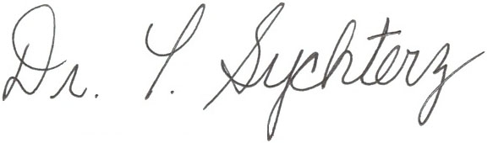
Terre Sychterz Chair, KU Children’s Literature Conference

